

FOR IMMEDIATE RELEASE

ETHAN CONRAD PROPERTIES CLOSES ESCROW
ON RENAISSANCE TOWER IN DOWNTOWN SACRAMENTO
Exciting Changes are Coming!

Sacramento, CA – December 10, 2024: Ethan Conrad Properties, a leading commercial real estate firm based in Sacramento, is excited to announce the successful closing of escrow on the Renaissance Tower, an iconic high-rise in the heart of Downtown Sacramento, yesterday.

In October, Ethan Conrad Properties had the winning bid of $21.4 million in the auction for this property. The purchase price is a fraction of what the building sold for in 2016 –
$80 million - highlighting a significant opportunity.

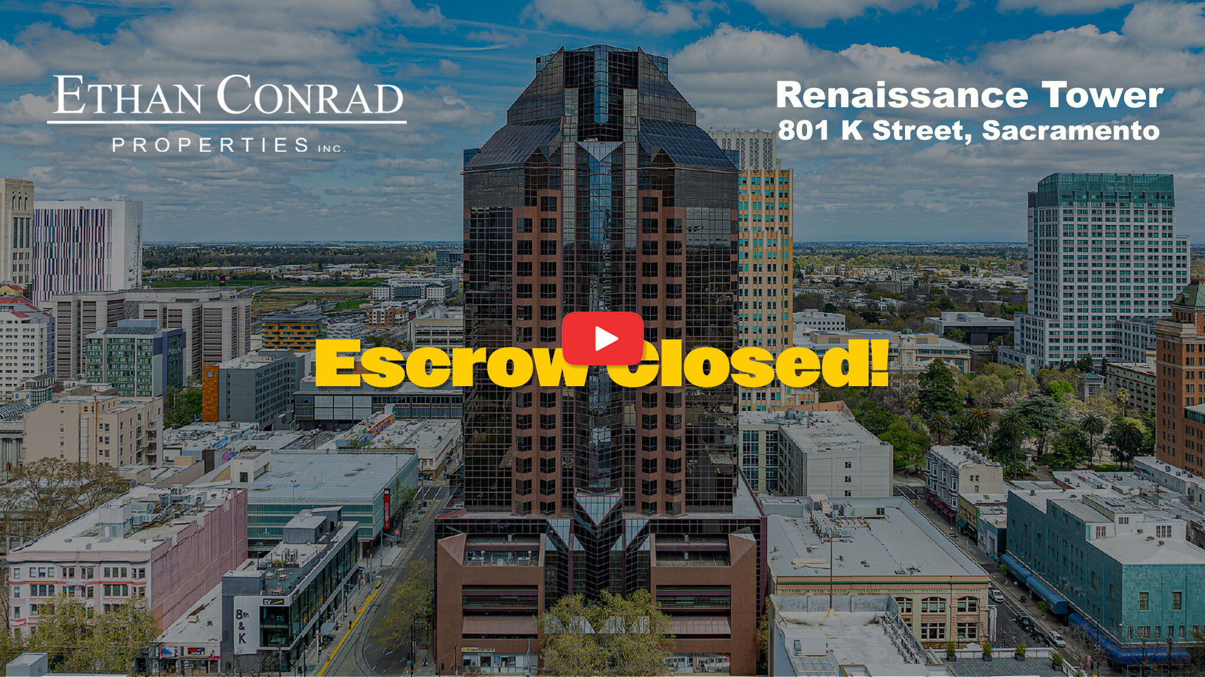
View the Renaissance Tower Announcement video.

This purchase highlights the company’s ongoing commitment to revitalizing the Sacramento region through strategic investments in prime commercial properties.

The Renaissance Tower, a 28-story Class A office building with 338,410 square feet of space and 500 garage parking spaces, stands out on the Downtown Sacramento skyline at 801 K Street. It’s a great example of Ethan Conrad Properties’ commitment to revitalizing properties by enhancing their appearance and functionality, addressing deferred maintenance, and boosting occupancy. The company takes pride in leasing transformed spaces like this to high-quality tenants who bring value to the communities they serve.

This acquisition marks a significant milestone for the company, as it has become the largest single office building in their portfolio. Standing nearly twice as tall as any other building owned by the company, the Renaissance Tower is one of the tallest structures in Downtown Sacramento.

With the addition of this impressive property, Ethan Conrad Properties now controls approximately 600,000 square feet of office and retail space — all within a single block, which includes:

- 801 K Street, Sacramento (Renaissance Tower)
- 630 K Street, Sacramento
- 770 L Street, Sacramento

This is a huge step forward, especially considering that just five months ago, the company had no presence in downtown Sacramento.

“We’re excited to add the Renaissance Tower to our portfolio,” said Ethan Conrad, CEO of Ethan Conrad Properties. “This acquisition reinforces our commitment to investing in Sacramento’s future and solidifies our position as a leader in commercial real estate. Its prime location and iconic design give us a unique chance to offer exceptional value to our tenants and the community.”

Plans for Renaissance Tower include upgrades like installing LED lighting to make the building stand out at night and preparing all available spaces to be in prime show condition, ready for immediate occupancy. The lobby remodeling will be completed with new artwork, plants, and other finishing touches. True to its reputation for revitalizing properties, Ethan Conrad Properties is committed to creating vibrant, productive spaces for businesses of all sizes.

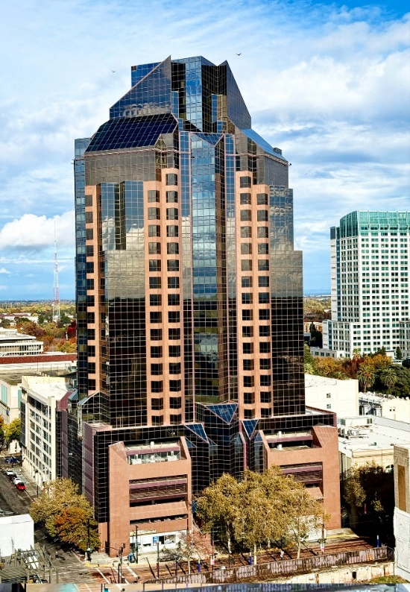 | 
The Renaissance Tower, a 28-story Class A office building at 801 K Street, Sacramento. | Renaissance Tower night-time  preliminary rendering with LED Lighting.

Situated in the heart of Downtown Sacramento, Renaissance Tower provides convenient access to the city’s vibrant cultural, dining, and entertainment scenes near DOCO.


Renaissance Tower’s lobby renovations are now completed!

For more information about Ethan Conrad Properties and its portfolio, please visit www.ethanconradprop.com.

About Ethan Conrad Properties
We’re based in Sacramento and have built a reputation as a premier commercial real estate investment firm, owning and managing a diverse mix of office, retail, and industrial properties across Northern California. We’re all about finding value-added opportunities —acquiring, renovating, and managing commercial spaces to provide top-quality locations for our tenants and great returns for our investors.

Contact Information

Contact: Mona Escudero, Ethan Conrad Properties, Inc.
Phone: (916) 779-1000
Email: mona@ethanconradprop.com

Address: 1300 National Dr., Suite 100, Sacramento, CA 95834
Website: https://ethanconradprop.com/

Facebook: https://www.facebook.com/ethanconradprop
Twitter: https://twitter.com/EthanConradPrp
LinkedIn: https://www.linkedin.com/company/ethan-conrad-properties-inc
Instagram: https://www.instagram.com/ethanconradprop/

###

